**Exercises**

**Count plots**

In this exercise, we'll return to exploring our dataset that contains the responses to a survey sent out to young people. We might suspect that young people spend a lot of time on the internet, but how much do they report using the internet each day? Let's use a count plot to break down the number of survey responses in each category and then explore whether it changes based on age.

As a reminder, to create a count plot, we'll use the catplot() function and specify the name of the categorical variable to count (x=____), the pandas DataFrame to use (data=____), and the type of plot (kind="count").

Seaborn has been imported as sns and matplotlib.pyplot has been imported as plt.

**Instructions 1/3**

* Use sns.catplot() to create a count plot using the survey_data DataFrame with "Internet usage" on the x-axis.

**script.py**

# Create count plot of internet usage

sns.catplot(x="Internet usage", data=survey_data, kind="count")

# Show plot

plt.show()

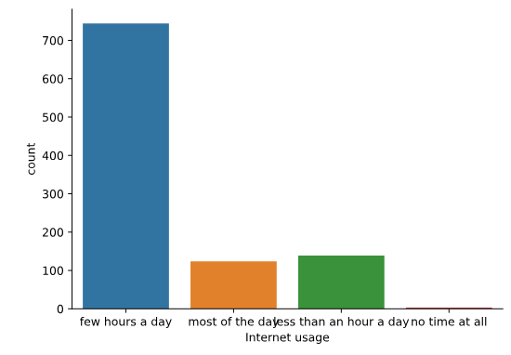

* Make the bars horizontal instead of vertical.

**script.py**

# Separate into column subplots based on age category

sns.catplot(y="Internet usage", data=survey_data,

            kind="count")

# Show plot

plt.show()

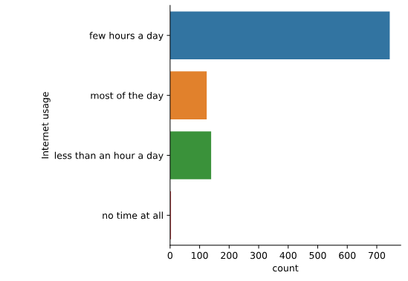

* Separate this plot into two side-by-side column subplots based on "Age Category", which separates respondents into those that are younger than 21 vs. 21 and older.

**script.py**

# Separate into column subplots based on age category

sns.catplot(y="Internet usage", data=survey_data,

            kind="count", col="Age Category")

# Show plot

plt.show()

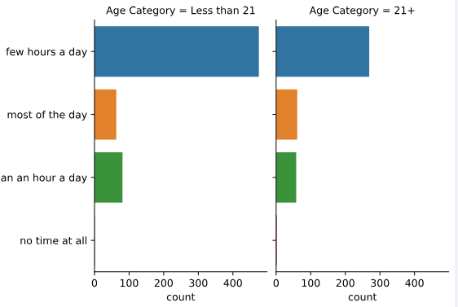

______________________________________________________________________________

**Bar plots with percentages**

Let's continue exploring the responses to a survey sent out to young people. The variable "Interested in Math" is True if the person reported being interested or very interested in mathematics, and False otherwise. What percentage of young people report being interested in math, and does this vary based on gender? Let's use a bar plot to find out.

As a reminder, we'll create a bar plot using the catplot() function, providing the name of categorical variable to put on the x-axis (x=____), the name of the quantitative variable to summarize on the y-axis (y=____), the pandas DataFrame to use (data=____), and the type of categorical plot (kind="bar").

Seaborn has been imported as sns and matplotlib.pyplot has been imported as plt.

**Instructions**

**100 XP**

* Use the survey_data DataFrame and sns.catplot() to create a bar plot with "Gender" on the x-axis and "Interested in Math" on the y-axis.

**script.py**

# Create a bar plot of interest in math, separated by gender

sns.catplot(x="Gender", y="Interested in Math", data=survey_data, kind="bar")

# Show plot

plt.show()

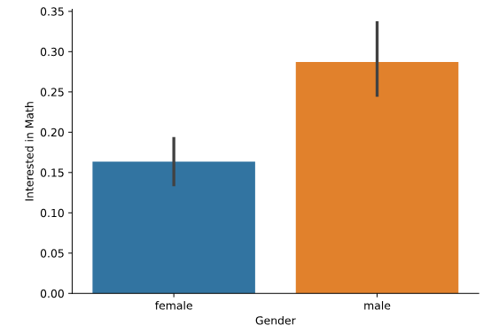

______________________________________________________________________________

**Customizing bar plots**

In this exercise, we'll explore data from students in secondary school. The "study_time" variable records each student's reported weekly study time as one of the following categories: "<2 hours", "2 to 5 hours", "5 to 10 hours", or ">10 hours". Do students who report higher amounts of studying tend to get better final grades? Let's compare the average final grade among students in each category using a bar plot.

Seaborn has been imported as sns and matplotlib.pyplot has been imported as plt.

**Instructions 1/3**

* Use sns.catplot() to create a bar plot with "study_time" on the x-axis and final grade ("G3") on the y-axis, using the student_data DataFrame.

**script.py**

# Create bar plot of average final grade in each study category

sns.catplot(x="study_time", y="G3", data=student_data, kind="bar")

# Show plot

plt.show()

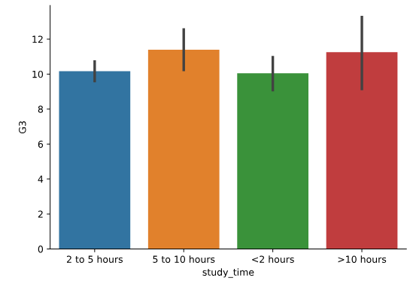

* Using the order parameter and the category_order list that is provided, rearrange the bars so that they are in order from lowest study time to highest.

**script.py**

# List of categories from lowest to highest

category_order = ["<2 hours",

                  "2 to 5 hours",

                  "5 to 10 hours",

                  ">10 hours"]

# Rearrange the categories

sns.catplot(x="study_time", y="G3",

            data=student_data,

            kind="bar", order=category_order)

# Show plot

plt.show()

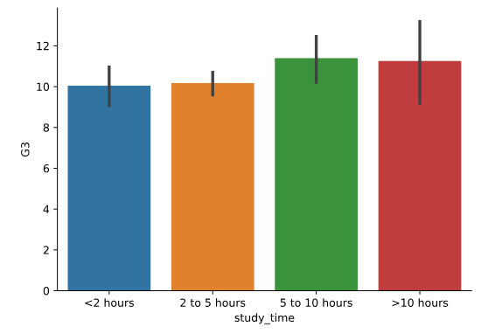

* Update the plot so that it no longer displays confidence intervals.

**script.py**

# List of categories from lowest to highest

category_order = ["<2 hours",

                  "2 to 5 hours",

                  "5 to 10 hours",

                  ">10 hours"]

# Turn off the confidence intervals

sns.catplot(x="study_time", y="G3",

            data=student_data,

            kind="bar",

            order=category_order, ci=None)

# Show plot

plt.show()

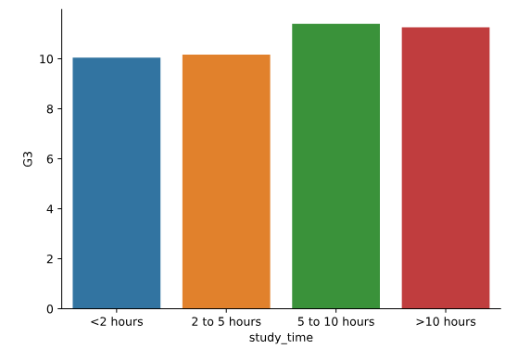

______________________________________________________________________________

**Create and interpret a box plot**

Let's continue using the student_data dataset. In an earlier exercise, we explored the relationship between studying and final grade by using a bar plot to compare the average final grade ("G3") among students in different categories of "study_time".

In this exercise, we'll try using a box plot look at this relationship instead. As a reminder, to create a box plot you'll need to use the catplot() function and specify the name of the categorical variable to put on the x-axis (x=____), the name of the quantitative variable to summarize on the y-axis (y=____), the pandas DataFrame to use (data=____), and the type of plot (kind="box").

We have already imported matplotlib.pyplot as plt and seaborn as sns.

**Instructions 1/2**

* Use sns.catplot() and the student_data DataFrame to create a box plot with "study_time" on the x-axis and "G3" on the y-axis. Set the ordering of the categories to study_time_order.

**script.py**

# Specify the category ordering

study_time_order = ["<2 hours", "2 to 5 hours",

                    "5 to 10 hours", ">10 hours"]

# Create a box plot and set the order of the categories

sns.catplot(x="study_time", y="G3", data=student_data, kind="box", order=study_time_order)

# Show plot

plt.show()

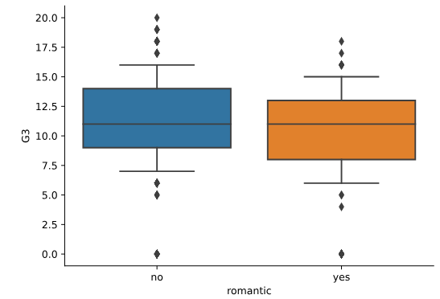

Change the code to set the whiskers to extend to the 5th and 95th percentiles.

**script.py**

# Set the whiskers at the min and max values

sns.catplot(x="romantic", y="G3",

            data=student_data,

            kind="box",

            whis=[5, 95])

# Show plot

plt.show()

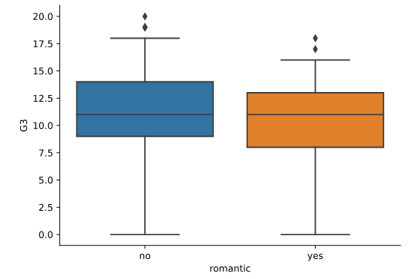

Change the code to set the whiskers to extend to the min and max values.

**script.py**

# Set the whiskers at the min and max values

sns.catplot(x="romantic", y="G3",

            data=student_data,

            kind="box",

            whis=[0, 100])

# Show plot

plt.show()

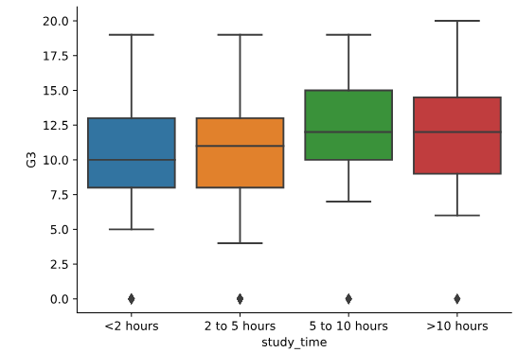

**Question**

Which of the following is a correct interpretation of this box plot?

**Possible answers**

The 75th percentile of grades is highest among students who study more than 10 hours a week.

There are no outliers plotted for these box plots.

The 5th percentile of grades among students studying less than 2 hours is 5.0.

The median grade among students studying less than 2 hours is 10.0.

______________________________________________________________________________

**Omitting outliers**

Now let's use the student_data dataset to compare the distribution of final grades ("G3") between students who have internet access at home and those who don't. To do this, we'll use the "internet" variable, which is a binary (yes/no) indicator of whether the student has internet access at home.

Since internet may be less accessible in rural areas, we'll add subgroups based on where the student lives. For this, we can use the "location" variable, which is an indicator of whether a student lives in an urban ("Urban") or rural ("Rural") location.

Seaborn has already been imported as sns and matplotlib.pyplot has been imported as plt. As a reminder, you can omit outliers in box plots by setting the sym parameter equal to an empty string ("").

**Instructions**

* Use sns.catplot() to create a box plot with the student_data DataFrame, putting "internet" on the x-axis and "G3" on the y-axis.
* Add subgroups so each box plot is colored based on "location".
* Do not display the outliers.

**script.py**

# Create a box plot with subgroups and omit the outliers

sns.catplot(x="internet", y="G3", data=student_data, kind="box", hue="location", sym="")

# Show plot

plt.show()

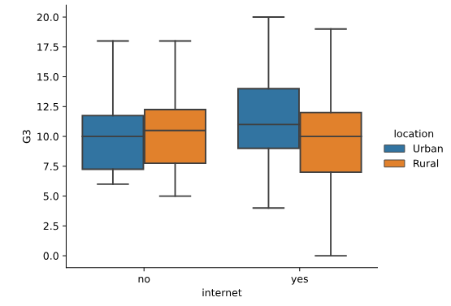

______________________________________________________________________________

**Adjusting the whiskers**

In the lesson we saw that there are multiple ways to define the whiskers in a box plot. In this set of exercises, we'll continue to use the student_data dataset to compare the distribution of final grades ("G3") between students who are in a romantic relationship and those that are not. We'll use the "romantic" variable, which is a yes/no indicator of whether the student is in a romantic relationship.

Let's create a box plot to look at this relationship and try different ways to define the whiskers.

We've already imported Seaborn as sns and matplotlib.pyplot as plt.

**Instructions 1/3**

Adjust the code to make the box plot whiskers to extend to 0.5 * IQR. Recall: the IQR is the interquartile range.

**script.py**

# Set the whiskers to 0.5 * IQR

sns.catplot(x="romantic", y="G3",

            data=student_data,

            kind="box",

            whis=0.5)

# Show plot

plt.show()

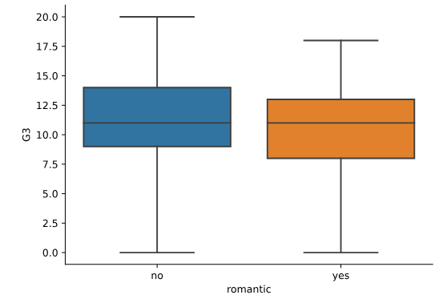

______________________________________________________________________________

**Customizing point plots**

Let's continue to look at data from students in secondary school, this time using a point plot to answer the question: does the quality of the student's family relationship influence the number of absences the student has in school? Here, we'll use the "famrel" variable, which describes the quality of a student's family relationship from 1 (very bad) to 5 (very good).

As a reminder, to create a point plot, use the catplot() function and specify the name of the categorical variable to put on the x-axis (x=____), the name of the quantitative variable to summarize on the y-axis (y=____), the pandas DataFrame to use (data=____), and the type of categorical plot (kind="point").

We've already imported Seaborn as sns and matplotlib.pyplot as plt.

**Instructions 1/3**

* Use sns.catplot() and the student_data DataFrame to create a point plot with "famrel" on the x-axis and number of absences ("absences") on the y-axis.

**script.py**

# Create a point plot of family relationship vs. absences

sns.catplot(x="famrel", y="absences", data=student_data, kind="point")

# Show plot

plt.show()

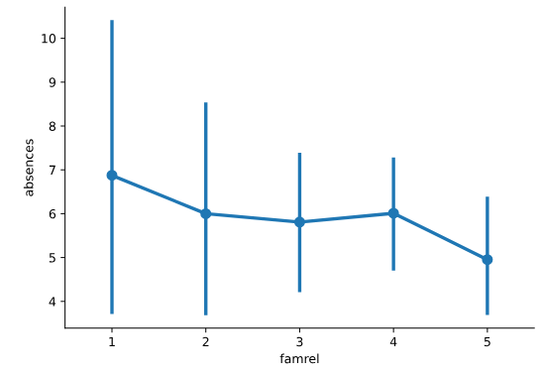

* Add "caps" to the end of the confidence intervals with size 0.2.

**script.py**

# Add caps to the confidence interval

sns.catplot(x="famrel", y="absences",

            data=student_data,

            kind="point", capsize=0.2)

# Show plot

plt.show()

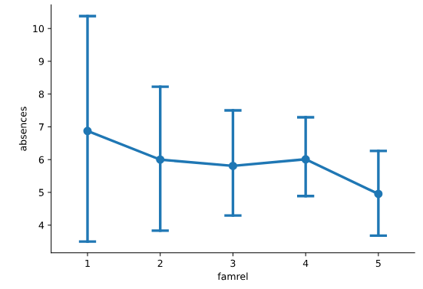

* Remove the lines joining the points in each category.

**script.py**

# Remove the lines joining the points

sns.catplot(x="famrel", y="absences",

            data=student_data,

            kind="point",

            capsize=0.2, join=False)

# Show plot

plt.show()

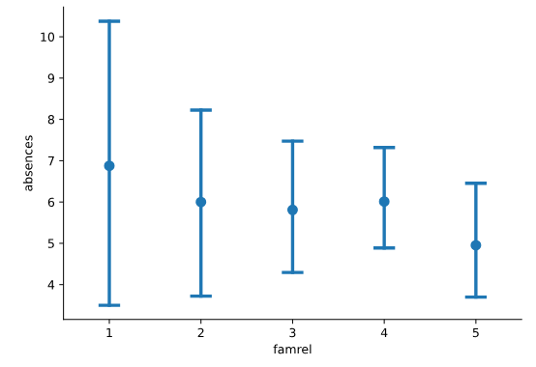

______________________________________________________________________________

**Point plots with subgroups**

Let's continue exploring the dataset of students in secondary school. This time, we'll ask the question: is being in a romantic relationship associated with higher or lower school attendance? And does this association differ by which school the students attend? Let's find out using a point plot.

We've already imported Seaborn as sns and matplotlib.pyplot as plt.

**Instructions 1/3**

* Use sns.catplot() and the student_data DataFrame to create a point plot with relationship status ("romantic") on the x-axis and number of absences ("absences") on the y-axis. Color the points based on the school that they attend ("school").

**script.py**

# Turn off the confidence intervals for this plot

sns.catplot(x="romantic", y="absences",

            data=student_data,

            kind="point",

            hue="school")

# Show plot

plt.show()

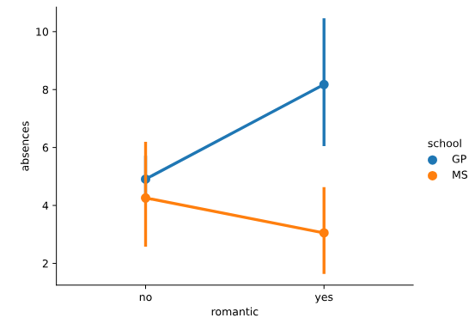

* Turn off the confidence intervals for the plot.

**script.py**

# Import median function from numpy

from numpy import median

# Plot the median number of absences instead of the mean

sns.catplot(x="romantic", y="absences",

            data=student_data,

            kind="point",

            hue="school",

            ci=None)

# Show plot

plt.show()

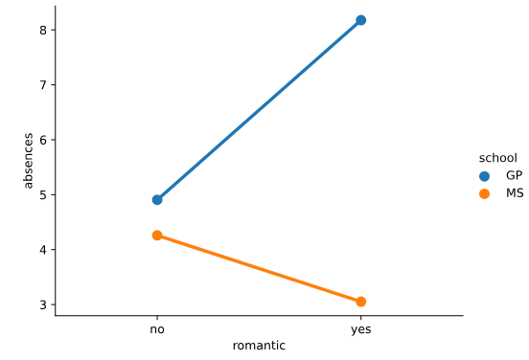

* Since there may be outliers of students with many absences, use the median function that we've imported from numpy to display the median number of absences instead of the average.



